**Option 1:**

* Use constants to define your environment and move to PROD dynamically.
* Steps
  + Create Workflow User Constraint called ‘Environment’ 🡪 This is used to switch value from Dev, Test and Prod in the process
  + Create 3 Workflow User Constraints to Maintain Path
    - PathDev
    - PathQA
    - PathPROD
  + Create Variable to Switch to Paths based on ‘Environment’ parameter let’s call it as ‘FullyQualifiedOutputName’

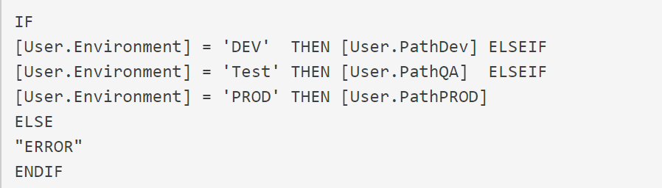

Snap shot of implementation in the Tool:

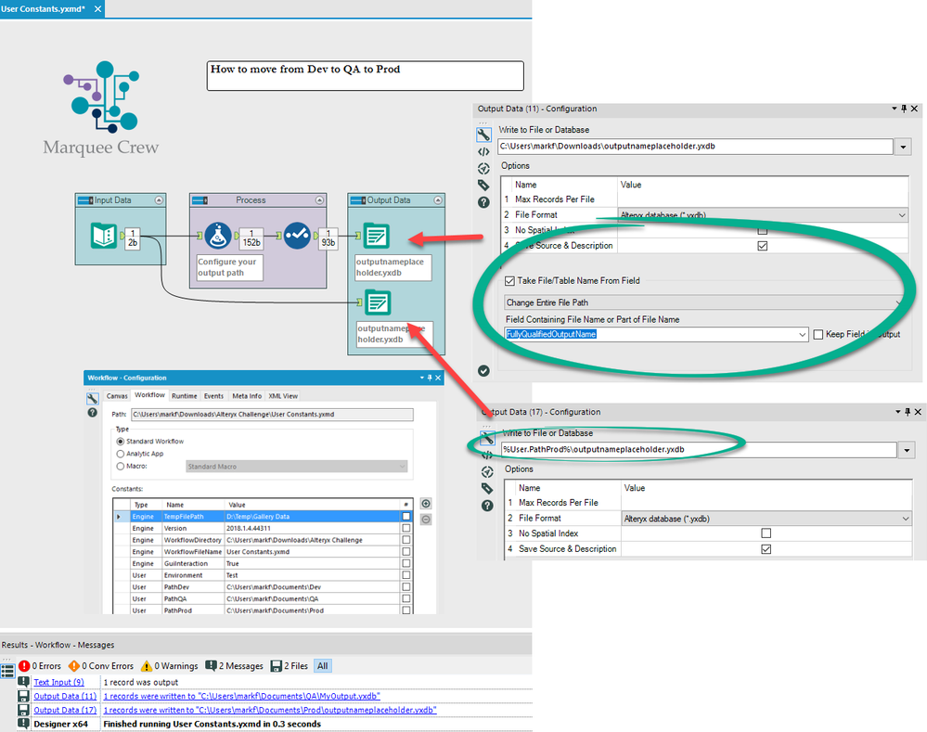

**Option 2:**

* Create 3 shared Connections in The Alteryx Gallery
* Go to Workflow Dependencies
* Change the alias to whichever one when moving environments (Change the part of after aka: with the new ID of the environment)

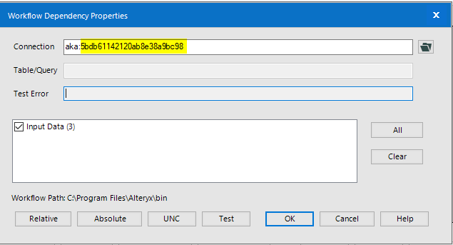

* Questions (If answers to below questions are Yes then above solutions works)
  + Are the test and prod have the same input systems?
  + Are they have the same schema and tables structure?
  + Do you have Single Alteryx Server for Dev and Prod?

References:

<https://community.alteryx.com/t5/Alteryx-Designer-Knowledge-Base/Moving-from-Dev-to-Prod/ta-p/158825>

<https://community.alteryx.com/t5/Alteryx-Designer-Discussions/Moving-workflows-between-Dev-Test-Prod/td-p/320384>

<https://community.alteryx.com/t5/Alteryx-Designer-Discussions/ODBC-connect-string-as-Workflow-Constant/td-p/488574>

<https://community.alteryx.com/t5/Alteryx-Designer-Knowledge-Base/Moving-from-Dev-to-Prod/ta-p/158825>